IFG Explore 1st Year
Term Four – Week Six Christmas Spiritual
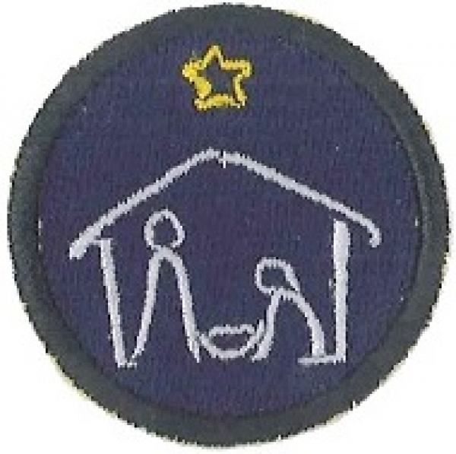
Aim: The Aim of this module is share the Christmas message with the girls and celebrate the birth of Jesus Christ

Objective:
- Continue to focus on Christmas and the birth of Jesus.

Preparation:
- Equipment for games as required.
- Christmas story for devotions, or further research on the Traditions of Christmas
- CD player and CD’s
- Material for whichever craft you decide to complete with your group.

Pre Set-Up:
Have a leader organise some Christmas games – see games section.

SetUp:
This is your usual formal start to the evening programme; girls will assemble at the Home Zone for marking the roll etc.

Devotions:
- Either present another Christmas story of your choice
- OR Look at the Traditions of Christmas around the world – some information and websites at end of this session.

Songs/Singing:
Follow on from the last two weeks.

Activity:
- Practice the Christmas puppet show.
- Choose one of the Christmas crafts listed below.

Christmas hair clip:
A dash of glitter and miniature Christmas lights or beads make this a sparkling craft for fashionable young girls

Equipment:
- Old hair clips (the kind that are round or triangle that snap back and forth work best)
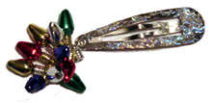
- Bright colored nail polish and/or glitter nail polish
- Clear nail polish (optional)
- Sparkles or craft glitter (optional)
- Tiny decorative light bulbs (see photo) with hole on end OR a selection of Christmas coloured beads.
- Fishing line (catgut)
- Scissors
- Super Glue may be needed if you are using the tiny lightbulbs.

How to make:
- Take your old hair clips and paint them with colored nail polish (you may want to paint them a certain colour to match outfits or you can paint them lots of different colors).
- After you have painted the clips with colours, you can let the nail polish dry and paint some more glitter nail polish over top for an extra touch. If you do not have any glitter nail polish, you can sprinkle craft sparkles or glitter over the colored nail polish when it is still wet.
- It is a good idea to put a coat of clear nail polish over the clips afterward if you are using craft glitter. Let dry.
- Take a piece of fishing line and string on some tiny light bulbs or beads.
- Put the fishing line through the hole on the end of the hair clip. Tie securely at each end.
- If you find that the light bulbs fall out of their socket, have an adult use Super Glue to glue them back into place.

Christmas table centre piece:
This Christmas arrangement craft is great for the girls to make as a table decoration or to give as a gift.

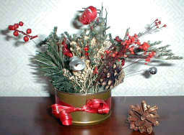
Equipment:
- Empty tuna fish, salmon, or cat food can (clean and dry)
- Gold spray paint
- Floral oasis
- Sprigs of holly, poinsettia, berries or other Christmas foliage.
- Star or other fun shapes – attach wire to these for the arrangement
- Moss or shredded tissue paper
- Ribbon
- Glue

How to make:
- Spray paint can and let dry.
- Place the floral foam inside the can.
- Tie a ribbon around the can and tie in a bow.
- Stick the various Christmas picks and other fun shaped picks in the floral foam until you have an arrangement that you like.
- Tuck some moss (or shredded tissue paper) around the base of the flowers to hide the foam.
- Makes a great table decoration for your table or to use as a gift.

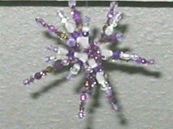
Beaded Star Tree Trims
Quick and easy Christmas ornament using coloured beds.

Equipment:
Craft beads in assorted colour
Chenille pipes

How to make:
Cut five coloured chenille stems into 4 x ½inch lengths (gold looks nice and adds glitter). Cut five white chenille stems into 3-1/2 inch pieces.
Lay three of the coloured stems on the table, top with the five white stems and then with the last two gold stems. Wire these together in the centre with a small piece of either coloured stem, and snip off excess wire.
You can vary the look of these beaded stars by changing the colours of the chenille stems and the beads, both of which are available at most dollar stores for a reasonable price.
Fan out the star "rays" in all directions, alternating colours.
Now slip beads in place, allowing some space between beads.
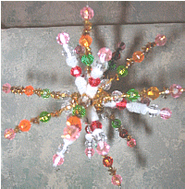
A huge amount of creativity is possible with this small Christmas craft. You may decide to make an all golden star, with only gold rays and golden beads; or a twinkling star with gold and silver rays and only transparent or silver beads.

Closing Prayer:

Notices and home time:
Notices this week will need to have all the details on it for your “Final Fling” night.

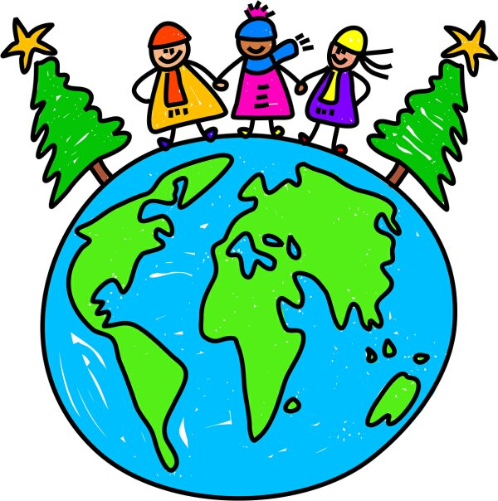
Christmas around the world:
The following are customs from just a few countries. Further information is available by going to
http://kids.yahoo.com/directory/School-Bell/Social Studies/Religion/Christianity/Christmas/Christmas-Around-the-World

http://www.soon.org.uk/country/christmas.htm
In Italy, children receive gifts from the good witch La Befana, old, bent and dressed in black. La Befana was a widowed, childless woman when the Three Kings passed on their way to see the Christ child. When they asked her the way to Bethlehem she was busy cleaning and sent them away. Realizing her mistake, she left to search for the Baby Jesus. To this day she is still searching going from house to house on Epiphany, January 6, leaving a gift for good children.
Russian children await gifts from Babouska, a farmer's wife who offered food and shelter to the Three Wise men on their journey to Bethlehem, Baboushka declined their offer of travelling with them to visit the Christ child. Realizing her error on the eve of Epiphany, she tried unsuccessfully to find them, but handed the presents she had intended for the infant Jesus to children she passed along the way.
In Spain, Mexico, Puerto Rico and South America, the Three Kings or Wise Men bring Christmas gifts to children, while in France children eagerly await the coming of Father Christmas or Pere Noel who brings their gifts.
In some cultures, Saint Nicholas travels with an assistant. The old bishop Sinterklass arrives in Holland on December 6 in his red bishop's costume astride a white horse. In many port towns, he is said to have sailed in on a ship from Spain. Beside him walks Black Peter with a black sack and a book recording each Dutch child's behavior through the year. Good children receive a gift from the bishop while bad children may be carried away in Black Peter's sack.
In Germany Saint Nicholas also travels with a helper, known as Knecht Ruprecht, Krampus, or Pelzebock, and comes with a sack on his back and a rod or switches in his hand. Saint Nicholas gives gifts to good children, while those who have been bad are punished by the assistant with a few hits of a switch.
Swedish children wait for the gnome Jultomten, also called Julemanden or Julenisse, who dresses in red and carries a sack of gifts on his back. He flies in his sleigh pulled by the Julbocker, the goats of Thor, the god of thunder. Elves, called the Juul Nisse, hide in the attics of families throughout the year, eagerly waiting to help him. Children leave bowls of milk or rice pudding in the attic for the elves, hoping they will be empty in the morning.
In Austria and Switzerland it is Christkindl or the Christ Child who arrives bearing gifts. In some towns children await the Holy Child and in others Christkindl is a beautiful girl-angel who comes down from heaven bearing gifts.

